Table of Contents: 1
1. Background 2
A- Introduction to the context: 2
B- History of the Region; Azaz; Northwestern Syria 2
2. Problem: Crisis Challenge 3
A- The Current Crisis and Its Impact 3
B- Challenges 3
3. Competition Task 4
A- Call to entry: 4
B- Objectives and Goals: 4
C- Response: Specific Tasks and Expectations 5
4- Design Programme: 5
A- Detailed Program: 5
B- Limitation: 6
5- Competition Site: 6
A. Site Description and Significance: 6
6- Criteria for Evaluation: 7
A. Design: 7
B. Functionality: 7
C. Execution: 7
7- Competition Schedule: 7
A. Timeline: 7
8- Registration: 8
A. Eligibility: 8
B. Registration: 8
C. Regulations: 8
9- Submission Requirements: 9
10- Awards and Certificates 9
11- Jury: 9
12- Data Package: 11
13- About Molham Volunteering Team: 11
14- About Mimaria Studio: 12

1. Background

A- Introduction to the context:
In these challenging times, the situation in Syria has highlighted how deeply war and natural disasters can disrupt lives. For thirteen years, the Syrian conflict, combined with the latest earthquake in February 2023, has displaced over 12.5 million people, making it one of the most significant displacements we've seen. Over a decade of devastating conflict has scarred Syria's socio-cultural fabric and severely damaged buildings and infrastructure, leaving millions homeless. Families have lost their homes, sense of safety, and place in the world.
In architecture, the term 'dwelling' transcends the physical realm, embodying a sense of tranquility, safety, and belonging - elements the victims of displacement have lost. Home is more than just four walls and a roof; it is a space that nourishes a sense of identity, community, and security. As such, what is required is more than providing temporary relief or basic shelter for these displaced communities. The necessity is for long-term, sustainable solutions that address the root causes of their situation and work towards their reintegration into the social fabric, enabling them to reclaim their sense of 'dwelling.'
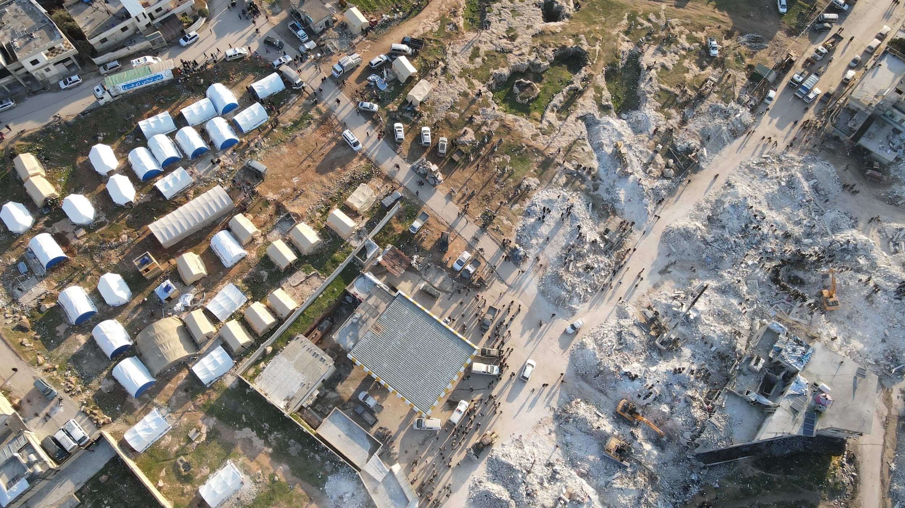

B- History of the Region; Azaz; Northwestern Syria
The competition site takes place in Azaz. A district near Aleppo city, located northwest of Syria, has a rich and diverse history that reflects the region's broader stories. It has been a critical place for many empires and civilizations, as a vital fortress town and a main battleground during different periods. After Syria gained independence in 1946, Azaz became the center of its district.
During the Syrian Conflict, Azaz became a stable place in the middle of chaos. This stability has brought many NGOs to the area to start housing projects, giving shelter and help to those affected by the conflict. Its secure setting and location near the Turkish border make Azaz an excellent place for carrying out these projects. NGOs see the need for long-lasting housing solutions and have chosen Azaz as a central point for their work. As a hub for these projects, Azaz is providing a safe place, aiming to bring back stability, community, and hope to those who have lost their homes.
However, the earthquake severely tested Azaz's resilience on February 6, 2023. The tremors devastated the city, collapsing buildings and leaving many without shelter amidst the cold and rain. Despite the challenges, the spirit of the community remains unbroken. This catastrophe has underscored the urgent need for stable, safe housing and support for the recovery efforts, bringing to light the incredible resilience and hope of the Azaz community even in the face of compounded disasters.
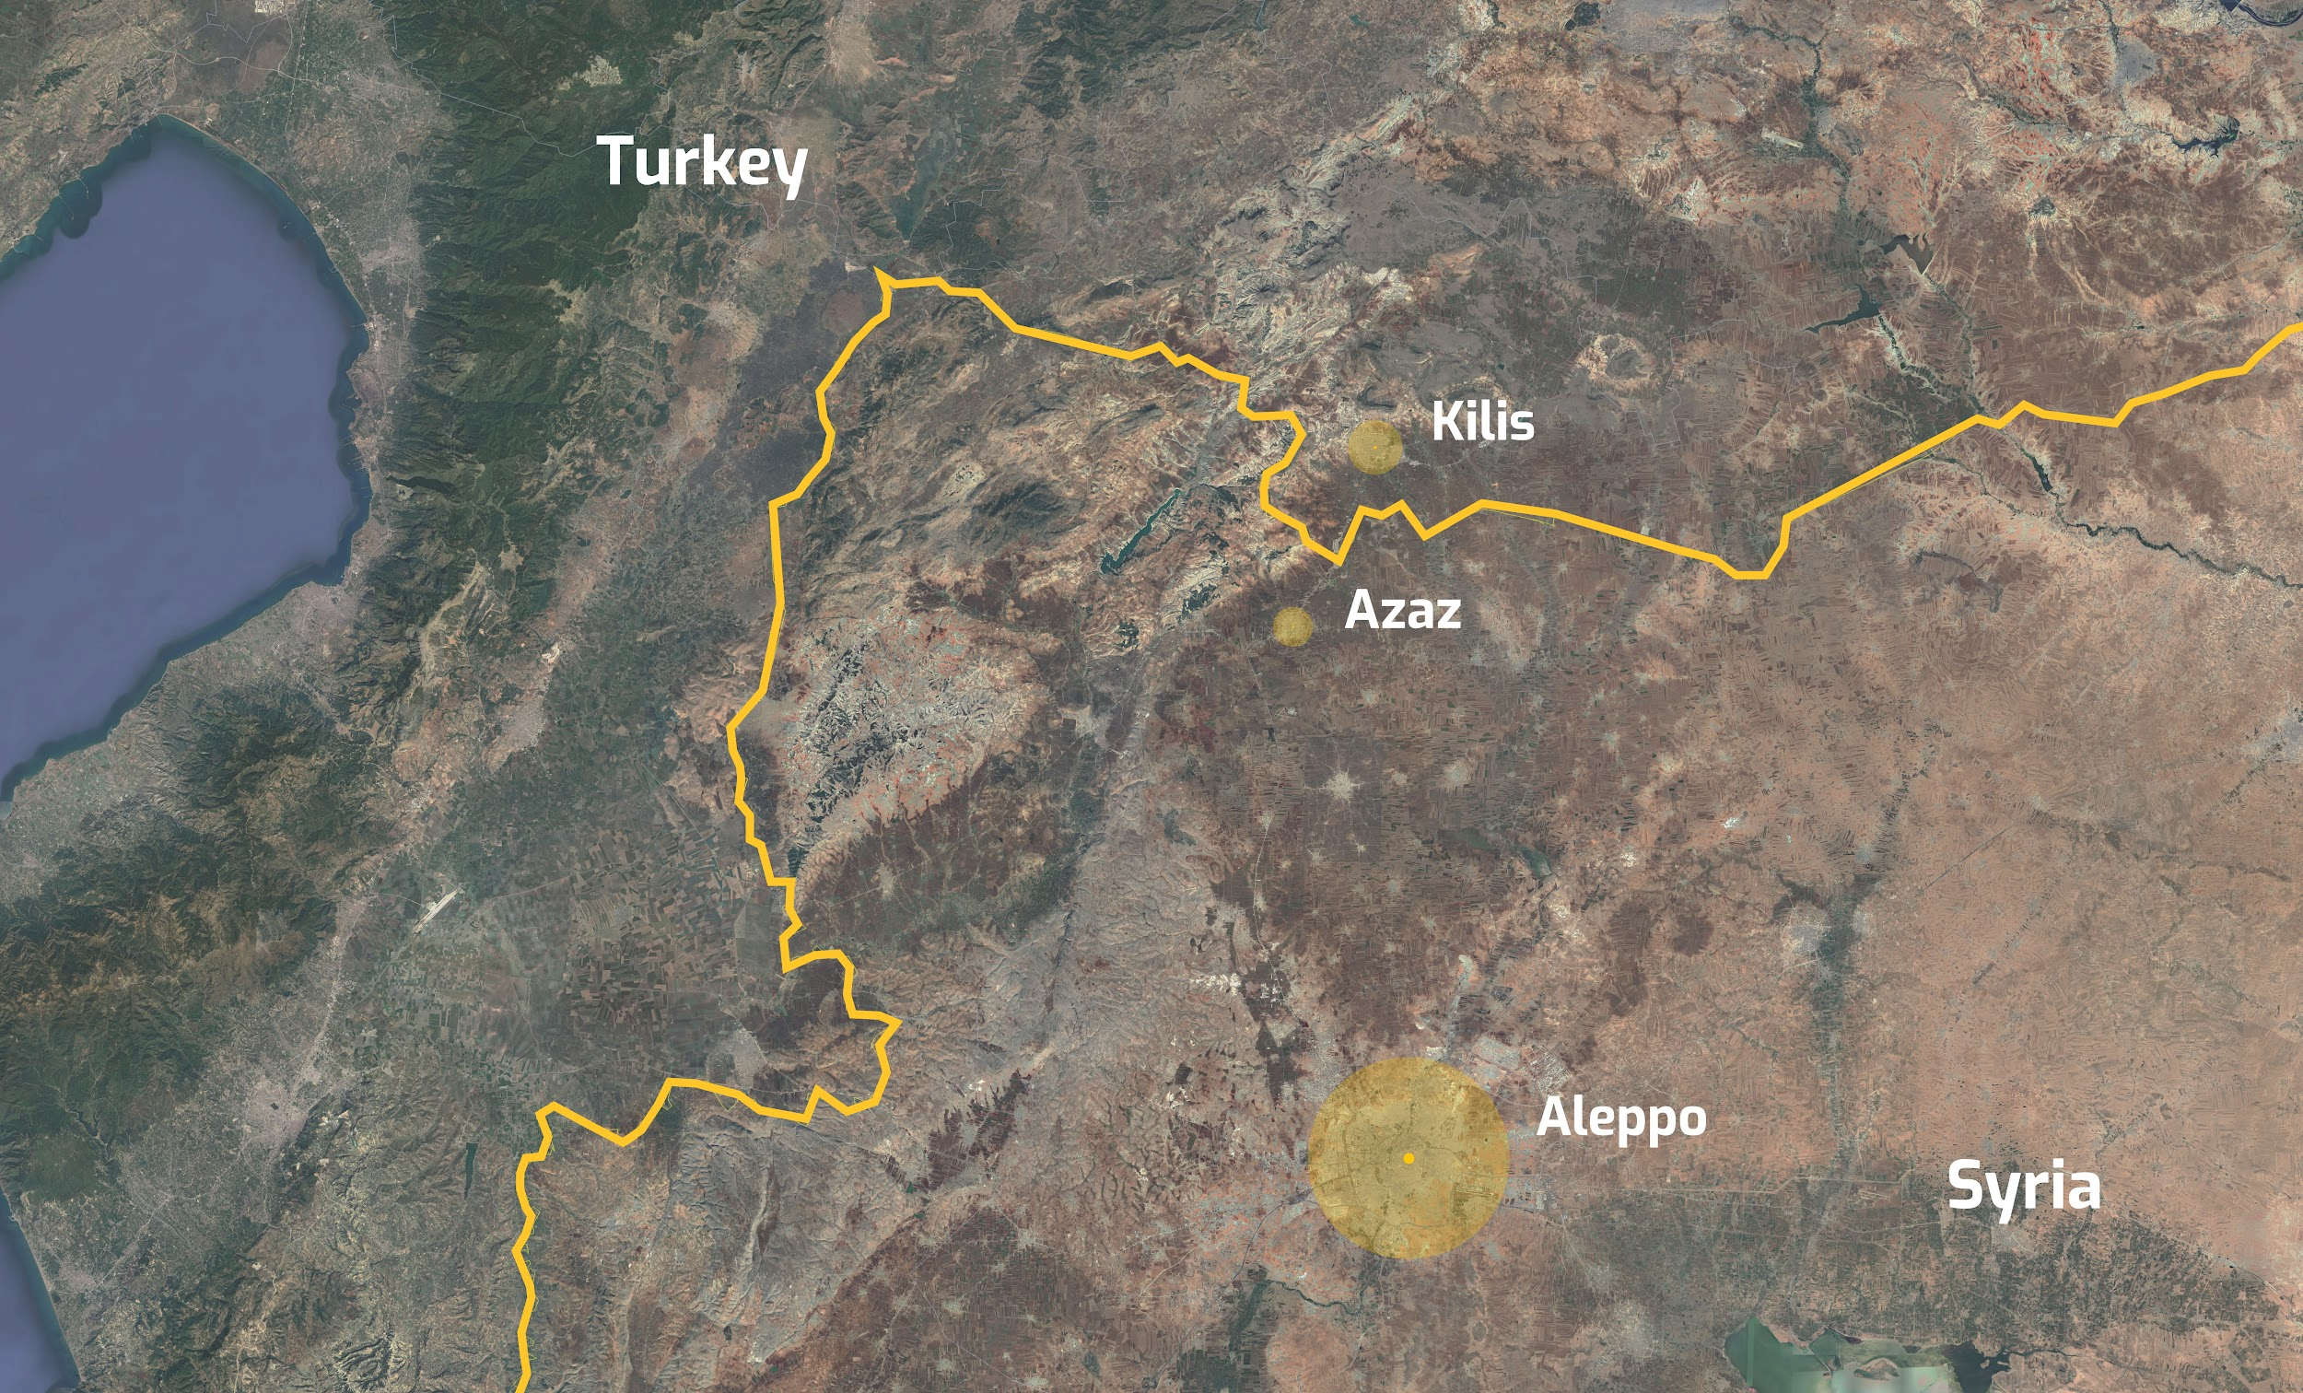

2. Problem: Crisis Challenge

A- The Current Crisis and Its Impact
The Syrian conflict, now in its thirteen years, has resulted in one of the most significant displacements in recent history. Over 12.5 million people have been forced from their homes, leaving a vast majority in dire need of shelter, security, and a sense of belonging. The socio-cultural fabric of Syria has been deeply scarred, with buildings and infrastructure severely damaged. This crisis, compounded by the latest earthquake, has left millions homeless and eroded the essence of 'dwelling' – a space beyond the physical that fosters a sense of identity, community, and security.

B- Challenges
- City:
  - Overcrowding: The ongoing conflict in Syria has forced more than 2.9 million people to seek refuge in the northwestern region, leading to significant overcrowding in districts like Azaz.
  - Use of Agricultural Land: The rapid development and need for emergency housing have led to the repurposing of agricultural lands, which can have long-term implications for local food security and the environment.
  - Environmental Impact: The swift and potentially unplanned development may have strained the area's environment, impacting soil quality, local flora and fauna, and the overall landscape.
  - Lack of Open and Public Areas: The area's primary use for emergency housing has resulted in a need for more dedicated public spaces, affecting the quality of life and community bonding.
- Internally Displaced People (IDPs):
  - Harsh Living Conditions: 90% of these displaced individuals live in substandard camps, facing severe climatic conditions and a lack of space and privacy.
  - Loss of Home and Community: The trauma of leaving their homes and communities behind has left a void, making it challenging to establish a new sense of belonging.
  - Lack of Affordable Housing: The sheer number of IDPs has led to a shortage of affordable housing options, further exacerbating their plight.
- NGOs:
- Resource Constraints: While NGOs have been at the forefront of providing relief, they often have to build quality projects with limited resources.
- Expertise in Rapid Housing: The immediate need for shelter requires NGOs to have expertise in building rapid and quality low-cost housing, a challenge given the scale of displacement.
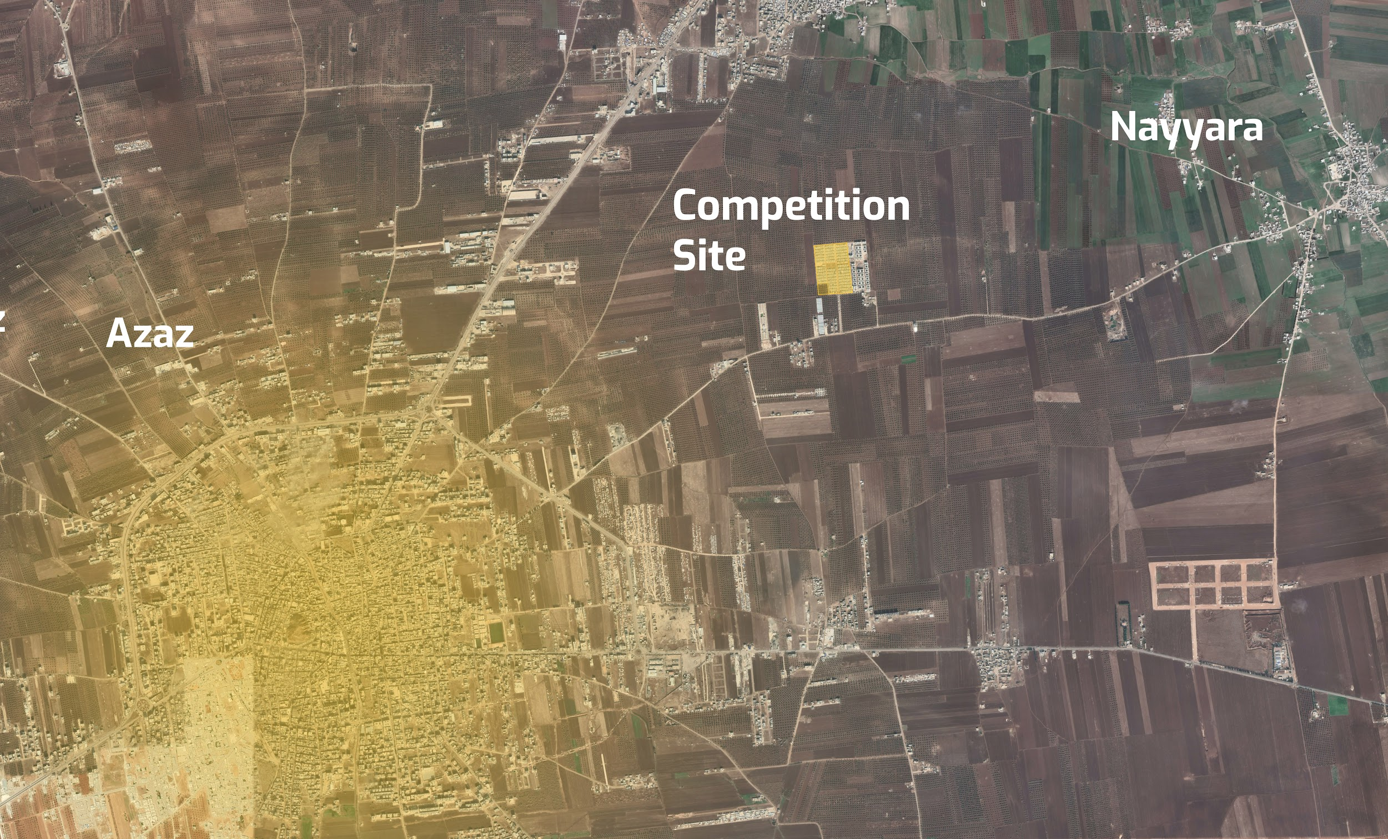

3. Competition Task

A- Call to entry:
We invite the international architectural community to rise to the challenge of designing innovative, sustainable, and culturally sensitive housing solutions for the earthquake victims of Syria. This competition seeks to address the complex crisis in Azaz by creating a new urban quarter that provides shelter and recreates a sense of home, community, and belonging.

B- Objectives and Goals:
- Innovative Solutions: To discover new design solutions beyond temporary relief, working towards long-term reintegration of the displaced into the social fabric.
- Cultural Sensitivity: To create designs that reflect the local culture and accommodate the diverse backgrounds of the inhabitants, fostering a sense of identity and community.
- Sustainable Practices: To promote sustainable design practices considering energy efficiency, environmental impact, and local and available materials.
- Community-Oriented Design: To develop layouts encouraging community interactions, creating safe and engaging public spaces, and fostering a sense of belonging.
- Scalability and Replicability: To find scalable design solutions that can be replicated in similar contexts, allowing for potential expansion or adaptation to different scenarios.

C- Response: Specific Tasks and Expectations
- Design a Housing Complex: Participants are tasked with designing a housing complex that accommodates 450 families, incorporating cultural, commercial, educational, and public functions.
- Balance Social Responsibility and Community Diversity: The design must harmoniously balance social responsibility, community diversity, and vibrant public spaces, curating spaces that spark interactions and nurture a sense of community.
- Create Resilient and Adaptable Spaces: The design must be earthquake resilient and adaptable, considering future scenarios, changing community needs, and integrating public and private functions to foster a cohesive community fabric.
- Consider Cost Efficiency and Construction Feasibility: The design must be realistic, feasible, and cost-efficient, considering local resources, available skills, and budget constraints.
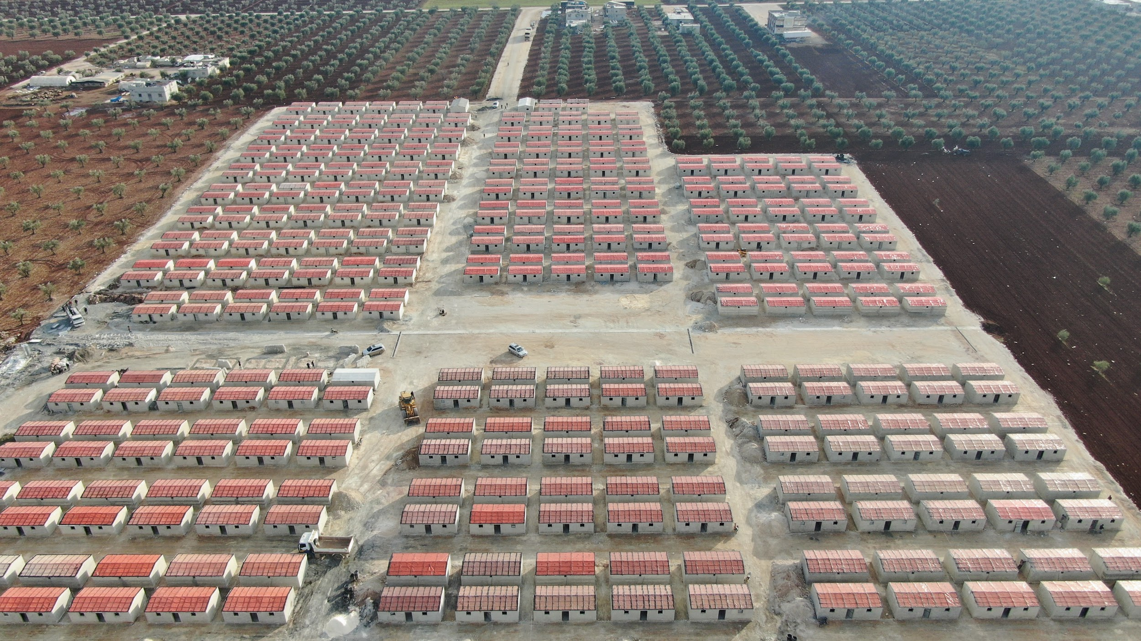

4- Design Programme:

A- Detailed Program:
- Area: 48.300 m²

- Housing Units:
  - Total: 450 units
  - Typology: Apartment blocks.
  - Height: 3 - 4 stories
  - Distribution: 4 housing units per floor.
  - Unit Types: 30% three-room units, 70% two-room units. (Read the Unit's specifications in the limitation part)

- Community Facilities:
  - Public Square (4000 m²): A vibrant community square integrated with the commercial stores and bakery, designed for gatherings and events.
  - Youth Center (1500 m²): Multi-purpose hall, library, workshop rooms, and separate sports halls (GYM) for women and men.
  - Mosque (400 m²): A space for community prayers, accommodating both men and women in separate areas.
  - School (2500 m²): A primary school spread over two to three floors, featuring 18 classrooms, sports fields for football and basketball, dedicated teacher's rooms, and external restrooms.
  - Commercial stores and Bakery (700 m²): Integrated with the public square, commercial stores (25m2 per store), and bakery with production facilities.
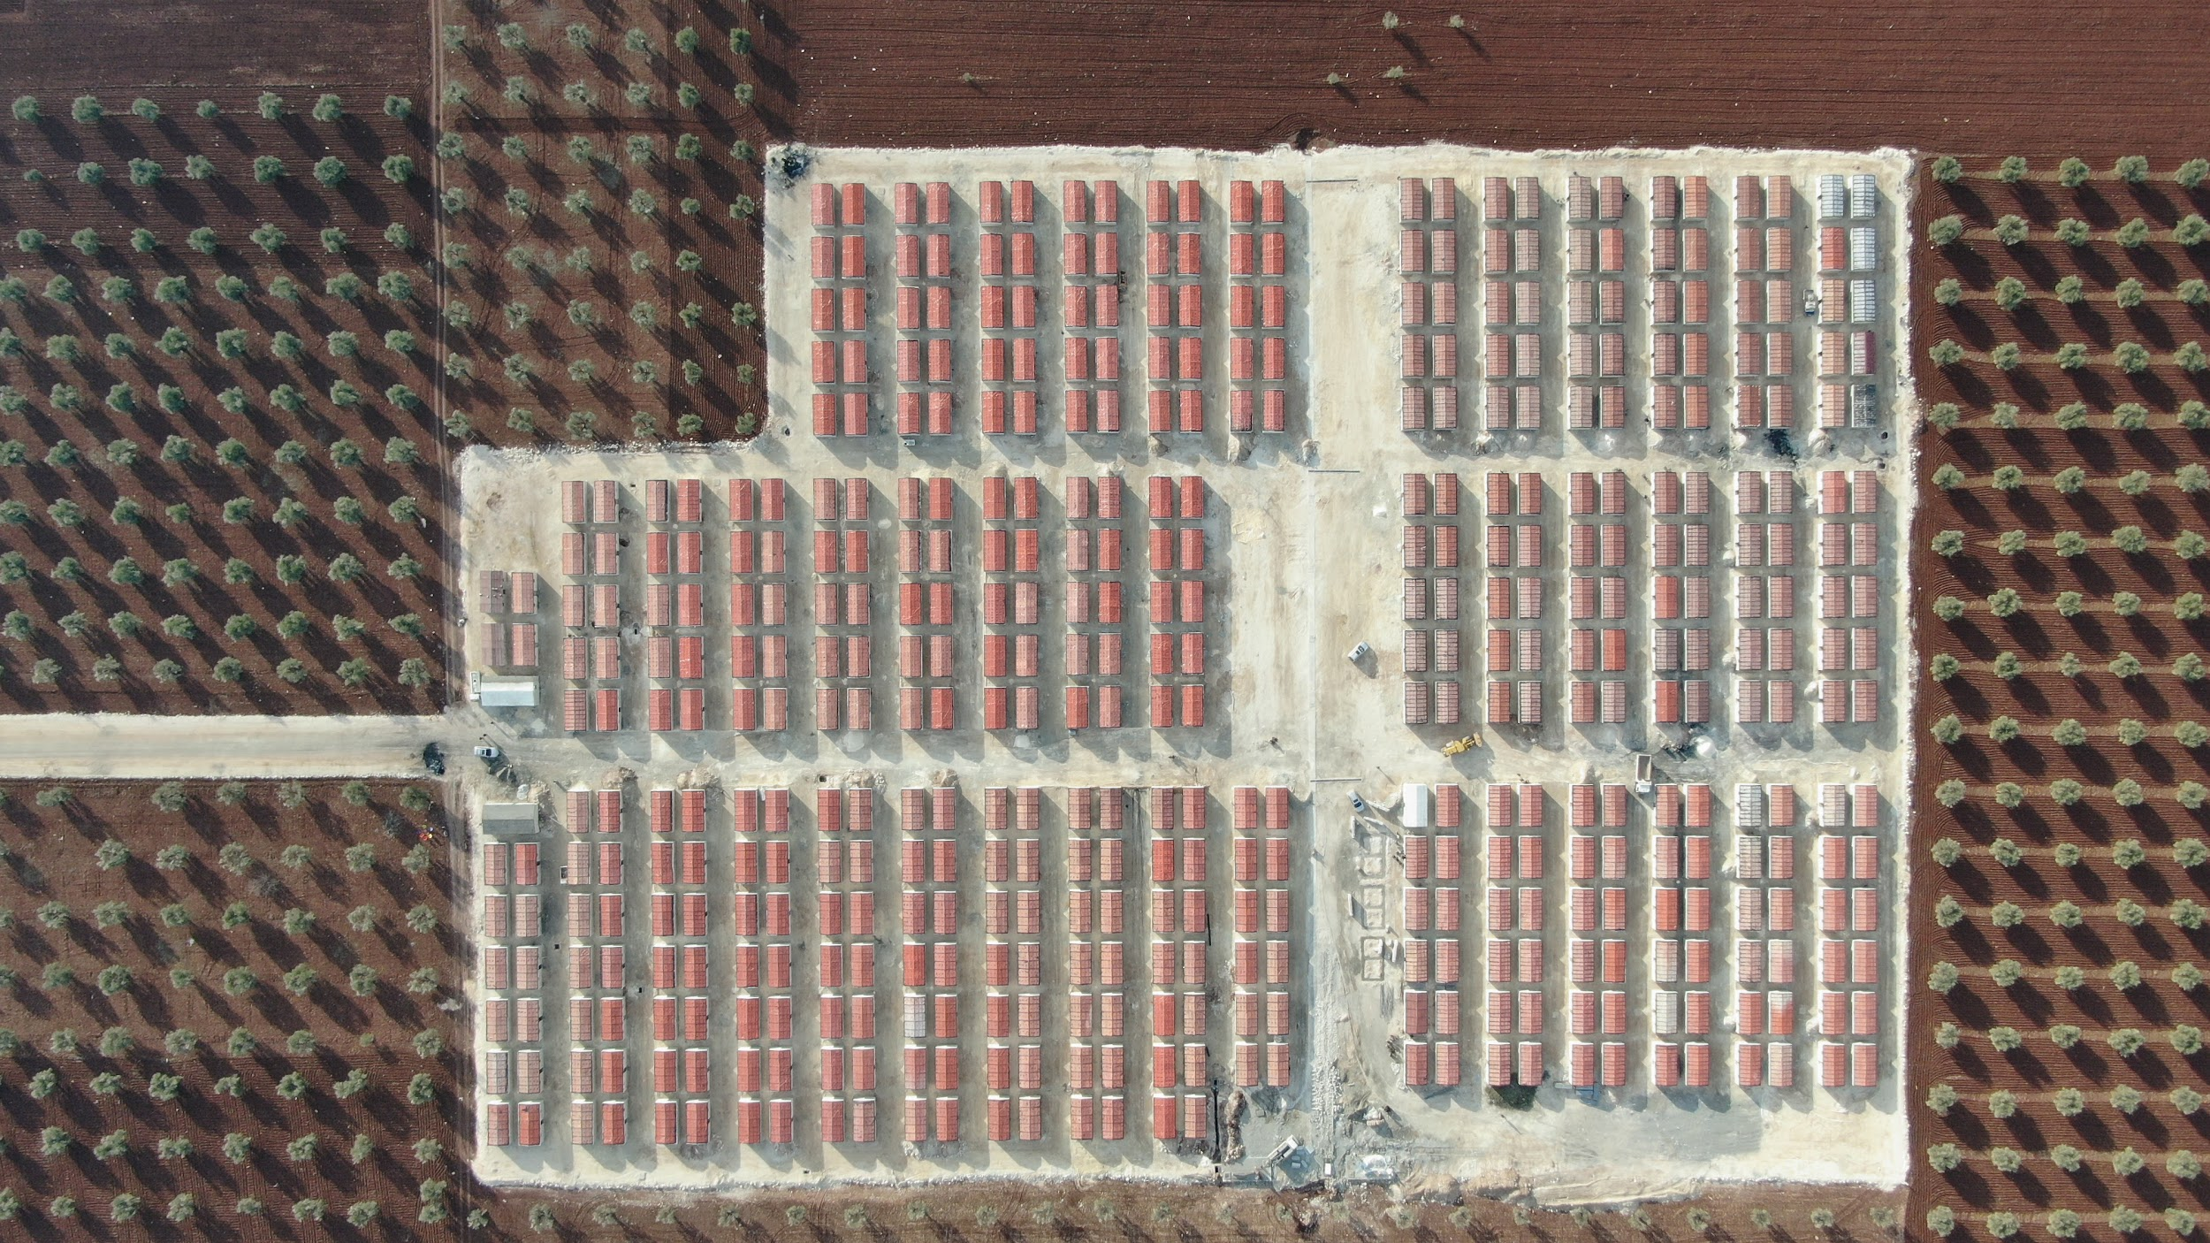

B- Limitation:
- Building Height:
  - Designs should not exceed four stories high, including the ground floor.

- Residential Unit Specifications:
Module 01 (2 rooms)
  - Size: 65 m².
  - Configuration: Two rooms with a kitchen and two bathrooms (one must have a shower cabin).
Module 02 (3 rooms)
  - Size: 75 m².
  - Configuration: Three rooms with a kitchen and two bathrooms (one must have a shower cabin).
Each floor should accommodate four units.
- Architectural Features:
- Cantilevers: Cantilevers should not exceed (1.5 m)
- Remember, any new construction space increases the building cost
- Construction Constraints:
- Adherence to the specific construction limitations provided in the supplementary file is mandatory.

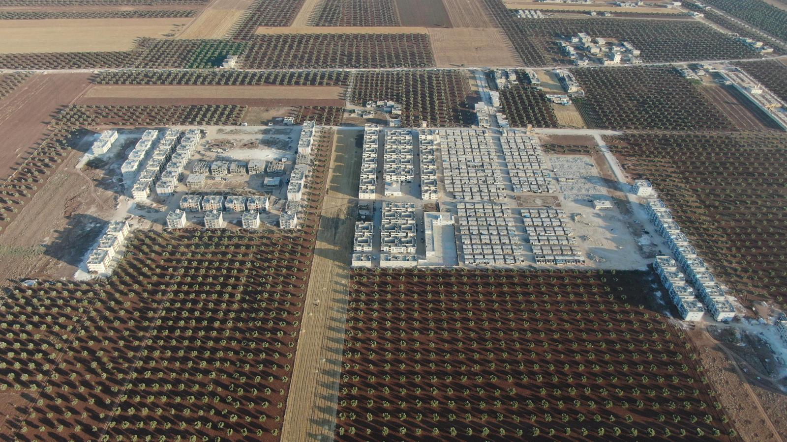

5- Competition Site:

A. Site Description and Significance:
Location: The competition site is strategically located on the main road between Nayarah and Azaz in Northwestern Syria. This region has emerged as a stable hub amid the chaos of the Syrian Conflict, attracting NGOs to implement housing projects for those affected.
Historical Value: The site bears significant historical value as a testament to the resilience of the local community in the face of adversity. Originally agricultural land, it has been repurposed multiple times to meet the community's changing needs, providing shelter to displaced persons and symbolizing the region's ongoing efforts to provide stable, secure housing.
Current Use: Encircled by various Molham housing projects, the site offers a unique perspective on the housing situation in Azaz. It has previously been utilized as a temporary housing area by the Molham Volunteering Team, reflecting the city's struggles and triumphs.
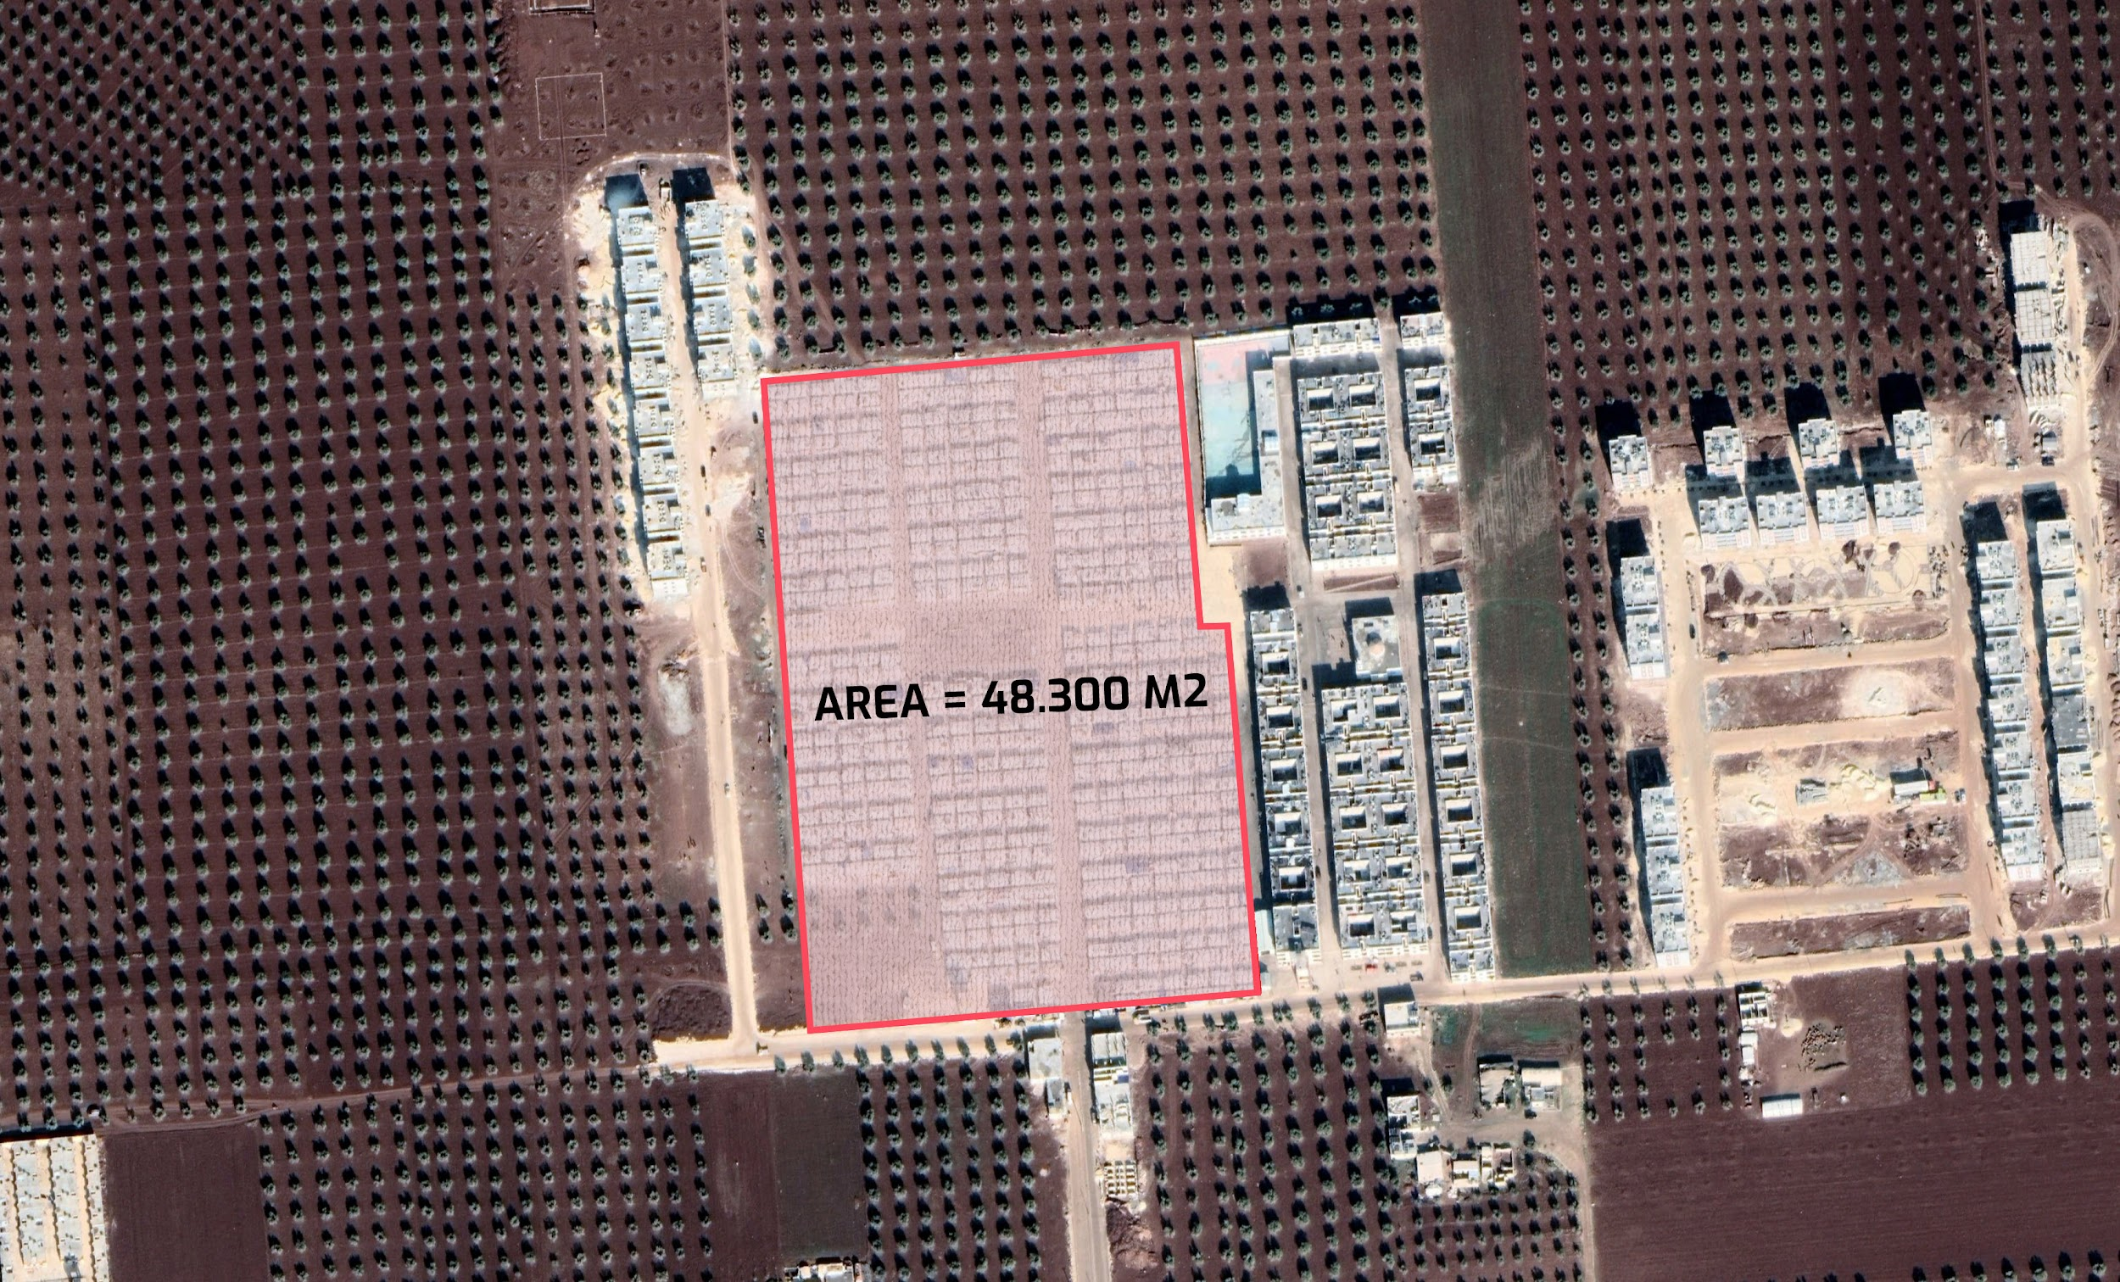

6- Criteria for Evaluation:

A. Design:
- Community-oriented Design: Promote community interactions and foster a sense of belonging, enhancing the community's social fabric.
- Sustainability: The incorporation of sustainable practices, considering aspects such as energy efficiency and the use of local materials.
- Ownership and Sense of Belonging: Spaces that encourage personal connection and a sense of ownership among the residents.
- Resilient Urban Structure: The resilience to changing conditions, including climatic variations and potential earthquakes, ensures the structure's long-term viability.

B. Functionality:
- Adaptable Use of Space: Flexibility in design to accommodate evolving needs and functions, allowing for adaptable use of space.
- Social Inclusion: Foster a sense of ownership and support social integration through thoughtful planning of social functions and communal areas.
- Hierarchy: Exhibit a thoughtful organization of spaces and functions, creating a clear hierarchy that enhances usability and flow.
- Privacy: Ensuring private spaces within the community is crucial, balancing communal interaction with individual privacy needs.

C. Execution:
- Scalability: Design solutions that can be scalable or replicable in similar contexts, allowing for potential expansion or adaptation to other locations.
- Cost efficiency: Consideration of cost efficiency, including the choice of design module, construction techniques, and ease of construction, without compromising quality.
- Feasibility: Considering local resources, available skills, and budget constraints.

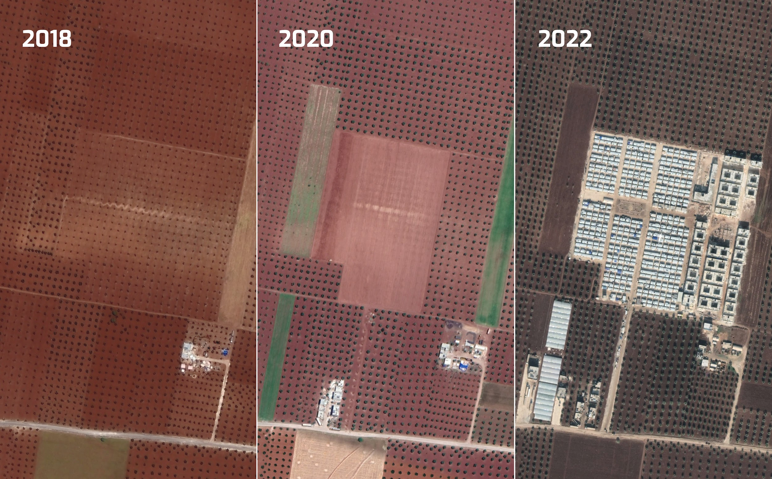

7- Competition Schedule:

A. Timeline:
March 15, 2024: Competition launch
April 25, 2024: Deadline for Receiving Questions
May 2024: Molham Projects seminar
July 30, 2024: Registration deadline
July 31, 2024: Submission deadline
August 2024: Shortlist announcement
August 2024: Winner announcement
All Deadlines are 11:59 pm GMT (London).

8- Registration:

A. Eligibility:
The competition is open to individuals and multidisciplinary teams of up to 8 members, including architects, urban designers, engineers, students, social workers, sociologists, and other design enthusiasts. Collaboration across specialties is encouraged to foster innovative and holistic solutions.

B. Registration:
- Students
- Early Registration: $30 until 25/04/2024
- Standard Registration: $40 until 25/06/2024
- Late Registration: $60
- Students who qualify for the shortlist will receive a refund of their registration fee.
- Architects / Experts / Offices
- Early Registration: $50 until 25/04/2024
- Standard Registration: $60 until 25/06/2024
- Late Registration: $80
- Institutional Registration: $300
This option is open for universities and other institutions interested in sponsoring their students to participate in International competitions and showcase their students’ work globally.

C. Regulations:
- This is an anonymous competition, and the Unique Registration Number is the only means of identification.
- The official language of the award is English.
- Contacting the jury is prohibited.
- As the award organizer, Mimaria Studio reserves the right to modify the schedule if necessary.
- Entries are only reviewed if rules or submission requirements are followed.
- Participation assumes acceptance of the regulations.
- By participating in this competition, entrants acknowledge that the Molham team retains the right to alter, adjust, or adapt the winning designs for implementation or other related purposes to ensure they comply with local regulations and are feasible. However, the designers will retain the intellectual property rights of the original designs.

9- Submission Requirements:
- A0 Board: Submit A0 boards (Maximum three boards) in JPEG format at 300 dpi resolution. Include all necessary information to explain your proposal, such as the modules plan, master plan, plans, sections, elevations, visualizations, and diagrams. Place the unique registration number in the upper left corner of the board in 22pt font.
- Project Statement: Include a Word file containing a concise project statement (maximum 250 words) explaining the design proposal.
- Main View: Provide an independent one view of the entry in JPEG format (16:9 ratio), preferably a bird's eye view of the project at 300 dpi resolution.
- Submission Method: Use the upload link in your registration confirmation email to submit your entry.
- Poster Layout: You should use landscape layout for your posters.
- Zip File Contents: Your submission should be contained in a zip file, including the A0 boards (JPEG – 300 dpi), 1 Word document (250 words max), and one central image (16:9) of the project (JPEG – 300 dpi).

10- Awards and Certificates
- 1st Prize - $2000 + Implementation possibility
- 2nd Prize - $1500
- 3rd Prize - $1000
- 20 Honourable Mentions + Certificate + Published work in publications, our website, social media pages, and exhibitions.

11- Jury:
- Christoph Wessling: Urban planner, Architect, & Academic
Brandenburg University of Technology (BTU)
Christoph Wessling is an urban planner and architect from Berlin with a distinguished career spanning over three decades in urban development planning and design. Since the early 2000s, he has been an influential researcher and lecturer at the Brandenburg University of Technology (BTU). His academic contributions include co-founding the double degree master's program in Urban Design - Revitalization of Historic City Districts, a collaboration with Cairo and Alexandria University initiated in 2014. From 2016 to 2019, Christoph dedicated his expertise as a mentor for the integrated urban development concept for Chernivtsi. In a significant role between 2020 and 2023, he served as the acting professor of Urban Planning and Urban Regeneration at the Technische Universität Berlin.
- Mouaz Abouzaid, Founder & Design Principal
Verform
Mouaz Abouzaid, a graduate of Alexandria University and the Founder & Design Principal of VERFORM, is a celebrated figure in the architecture industry, mainly known for his contributions in the Middle East. His visionary approach to architecture emphasizes sustainable, people-centric designs, reflecting his deep understanding of the interplay between human interactions and built environments. With over 17 years of experience, Mouaz has developed a rich portfolio that includes projects addressing critical societal issues. His notable project, Sheltainer City, ingeniously transformed shipping containers into functional living spaces for Cairo's low-income citizens. Another significant achievement is the X-Space project in Dubai, which earned the World Architecture Festival's top prize in the Smart Cities category. This project reinvented a section of Sheikh Zayed Road into a pedestrian-friendly green space.

- Islam Mosleh El Mashtooly, Architect, Urbanist, & founder
of Design & more
With over 19 years in architecture, El Mashtooly shines as the Design Director at OBM International. His work stands out for blending community values with cultural depth. At OBMI, he pioneered the AERA vertical resort, showcasing his commitment to sustainable design. His projects—Uptown Makkah, Etihad Airways HQ, and Shelter on the Edge—illustrate a unique approach that marries functionality with innovation. Before OBMI, he led designs at Perkins+Will, enhancing his portfolio with projects harmonizing with the MENA region's environment and culture. El Mashtooly's designs have earned global honor, including the "Future Projects'' award for his JANNAT MASJID project and being named among the Middle East's top architects, confirming his influential status in the architectural world.
- Ouessess Hummos, Architect, Urbanist, & Researcher
Mimaria Studio
An architect, urbanist, media practitioner, and researcher, he is dedicated to using his vast knowledge for the greater good. He aims to drive positive changes in society, politics, and urban spaces through activism and shaping policies. Currently, his efforts are centered on improving the lives of migrant communities and their integration into host societies. This focus reflects a deep commitment to addressing contemporary challenges and fostering environments where diverse populations can thrive together. His work is a testament to the belief that thoughtful design and informed policies can significantly impact communities and create more inclusive, supportive societies.

- Atef Nanoua, Architect, CEO, & Cofounder
Molham Volunteering Team
An architect and co-founder of the Molham Volunteering Team, he graduated in Architecture from Philadelphia University in Jordan in 2015. His significant contributions to both humanitarian and architectural fields are noteworthy. As the Executive Director of the Molham Volunteering Team, Nanou has played a vital role in overseeing various projects and initiatives, blending his architectural expertise with a passion for social good. He designed the Fahd Raee School in Azaz City, demonstrating a unique commitment to leveraging architecture for societal benefit.

- Yaser Biyoush, Senior Civil Engineer & Head of Engineering Department
Molham Volunteering Team
A senior civil engineer, Biyoush graduated from the University of Aleppo in 1984 and now heads the engineering department of the Molham Volunteering Team. With a career spanning several decades, he has led various engineering initiatives throughout Syria. Biyoush has a rich background, including ten years auditing structural studies at the Engineering Syndicate and supervising projects for a Dubai construction firm. His role with the Molham Volunteering Team showcases his dedication to leveraging his engineering expertise for humanitarian and development projects, aiming to make a significant impact within Syria.

- Abdulhadi Al Omar, Architect & Head of Architectural Department
Molham Volunteering Team
Al Omar, an architect at the Molham Volunteering Team, stands out for his design achievements. He's played a pivotal role in major projects, notably the renowned Gaza School in Northern Syria. Beyond educational facilities, his expertise in residential design demonstrates his ability to create meaningful architectural solutions. Al Omar's involvement with the Molham Volunteering Team underlines his dedication to leveraging architecture to enhance society and foster community development, showing his passion for making a positive impact through design.

12- Data Package:
- In the following link, you will find Cad files, images, videos, and useful reading documents:
Information Package

13- About Molham Volunteering Team:

In 2012, Molham Team was founded by a group of dedicated Syrian university students - young men and women who sensed the suffering of fellow Syrians who became refugees in neighboring countries, namely Jordan, Lebanon, and Türkiye. They refused to remain idle in the face of tragedy and were determined to lend a helping hand to refugees and alleviate their pain. Using every resource available, the volunteers have been striving to secure necessities, such as food, shelter, and medication for Syrians in need.
Following the relentless escalation of the Syrian conflict, the humanitarian crisis reached unprecedented levels, and the numbers of forcibly displaced Syrians multiplied rapidly within Syria and abroad. In response, the Molham Team expanded and assumed a more significant role in humanitarian aid and development. The Team now includes over 300 volunteers from around the world, who work together day and night to ensure that assistance is delivered to Syrians in need, as well as approximately 70 employees based in the areas of operations.
Today, Molham Team is proud to have consummated its achievements in the charitable, humanitarian field by establishing a nonprofit organization bearing its name, based in Türkiye. It has legal status and offices in Germany, Sweden, and Canada. Through this organization, the Molham Volunteering Team aims to develop a solid institutional framework for its humanitarian work, independent of any political orientation or partisanship.

14- About Mimaria Studio:
Mimaria Studio is a dynamic and renowned platform for Arab architects, offering an expansive network for over 7,000 members of the architectural community across the MENA region and beyond. It was founded by a group of immigrant architects who felt the necessity to create a hub to share architectural content in Arabic and shed light on the urban problems and challenges facing arab cities.
As the first Arab architecture community, Mimaria Studio stands out in the industry, providing a vibrant mix of educational programs, vocational training, and mentorship services. Our platform offers a unique, community-driven approach that encourages collaboration and skills development, allowing members to reach their full potential and significantly impact the architectural industry.
Mimaria offers workshops, seminars, and boot camps to equip architectural students and fresh graduates with the necessary skills to excel at university and in today's competitive job market. Additionally, Mimaria offers consultations, critiques, and a digital product store as a resource for our community. Headquartered in Istanbul, Türkiye, Mimaria Studio has been recognized as one of the top 5 Arab startups in the country.

Questions?
For any inquiries regarding the competition brief, please contact us before the deadline:
Email: info@mimariastudio.com.
Deadline for Queries: 25 April 2024

