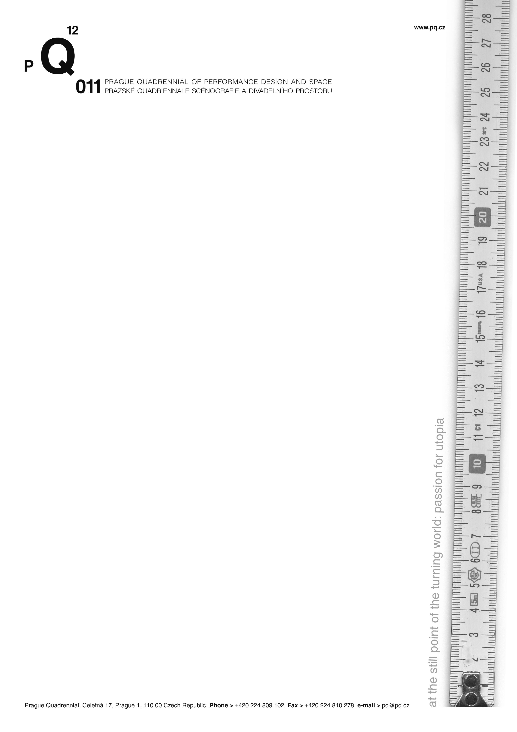
The 2011 Prague Quadrennial will take place in a new space – the Veletržní Palace

Time and place – these two variables have been set for the next Prague Quadrennial (PQ), the largest international event dedicated to stage design, performance, and space. The 12th PQ will take place in the Veletržní Palace (the building of the Czech National Gallery) from June 16th to June 26^{th,} 2011. The Veletržní Palace is only a few hundred meters away from PQ’s previous location, the Industrial Palace within the Prague Exhibition Grounds. In 2011, the functionalist building of the Veletržní Palace become the center of the PQ as it hosts the two main sections – the Section of Countries and Regions and the Student Section. Aside from the expositions, which will be spread on among several floors of the building, there will be a number of lectures and classes, as well as many other events. In addition, the artists will also visit the city center, as many shows, exhibitions, and performances will take place directly in the streets of Prague, on the piazzetta of the National Theatre, or in the building of the Theatre Academy.

”As for the Prague Quadrennial in 2007, there were almost 30,000 visitors and more than 5,000 professionals and students from all over the world. One of our aims for the upcoming PQ therefore was to look for a new place, which would not only correspond to the growing interest of the public, but would also be an important source of impulse for the PQ itself. The connection with the National Gallery offers new context for the Prague Quadrennial, which presents scenography as an artistic discipline between visual and performing arts,“ says Sodja Lotker, the PQ Artistic Director .

The main objective of the PQ is to draw attention to current works of scenographers and architects to the broader public. Apart from the professional aspect, the PQ’s organizers are planning to introduce a number of events meant for the general public and kids. At this moment there are 57 countries signed up to participate in the next PQ. There are a number of traditional PQ participating countries registered, such as the USA, Germany, and Norway, but also countries like India and Kazakhstan. For more detailed information, please go to www.pq.cz/en.

Preparations for the next Prague Quadrennial are already in full swing. Great attention, however, has turned to the new PQ project, the Intersection. It is a unique project combining workshops, symposia, and last but not least, the artistic event itself. The Intersection is clearly the most extensive project of its kind, connecting various fields and genres of contemporary art, related to performance and performance design – theatre itself, dance, art installations, video art, performance, body art, fashion, new media, architecture, and site-specific pieces, among others. As a result of several years of effort, there will be a performance/installation in the Prague city center, where people will be able to see performances throughout the day, or where one can see installations or video art. The importance of this project is not only marked by the participation of 8 other important institutions as Victoria and Albert Museum or Kretakör Theatre Company, but also the fact that the project was awarded the Culture Grant of the European Union, where it succeeded among 296 applications. The first part of the project – the international theoretical symposia took place in Autumn 2009 in Amsterdam and Zurich.

The quintessential element of the PQ program, however, will traditionally be connected to the Section of Countries and Regions. Individual country’s concepts will represent all current stage design directions: the stage, costume, lighting and sound design, etc. and their mutual connections. As in previous years, plenty of space will be also dedicated to the Student Section. Aside from the expositions of particular art schools from around the world, this section will also host the Scenofest – an educational project based in workshops and site-specific performances. The question, “what is a theatre now?” will be the main topic of the Architecture Section, which will mainly focus on the diversity of forms of theatre space in the 21st century. This section will not only take spectators from the theatre building to site-specific spaces and all the way to virtual space, also it will also create dialog among architecture, scenography, and contemporary performance.

The three main competitive sections of the Prague Quadrennial, where participating countries and artists may win the main prize, the Golden Triga, as well as other awards, will be accompanied by several programs meant to address the broadest international public. There will be a new project concerning costumes, a sound and light project, and the traditional PQ for Children project, which will take place directly in the streets of Prague.

The Veletržní Palace is one of the most important functionalist buildings in Prague. Built by Josef Fuchs and Oldřich Tyl, the building was completed in 1928 and was, in its time, highly praised for its size, modern concept, and unusual façade. The six floors of the building served its original purpose until 1939 when it began to be used for many different purposes. Destroyed by fire in 1974, the building was reconstructed in the early 1990s and today it serves as the home of 20th and 21st century art for the Czech National Gallery.

For more information please contact:
Ondřej Kopička
International PR
Prague Quadrennial
M: +420 608 540 360
E: press@pq.cz

