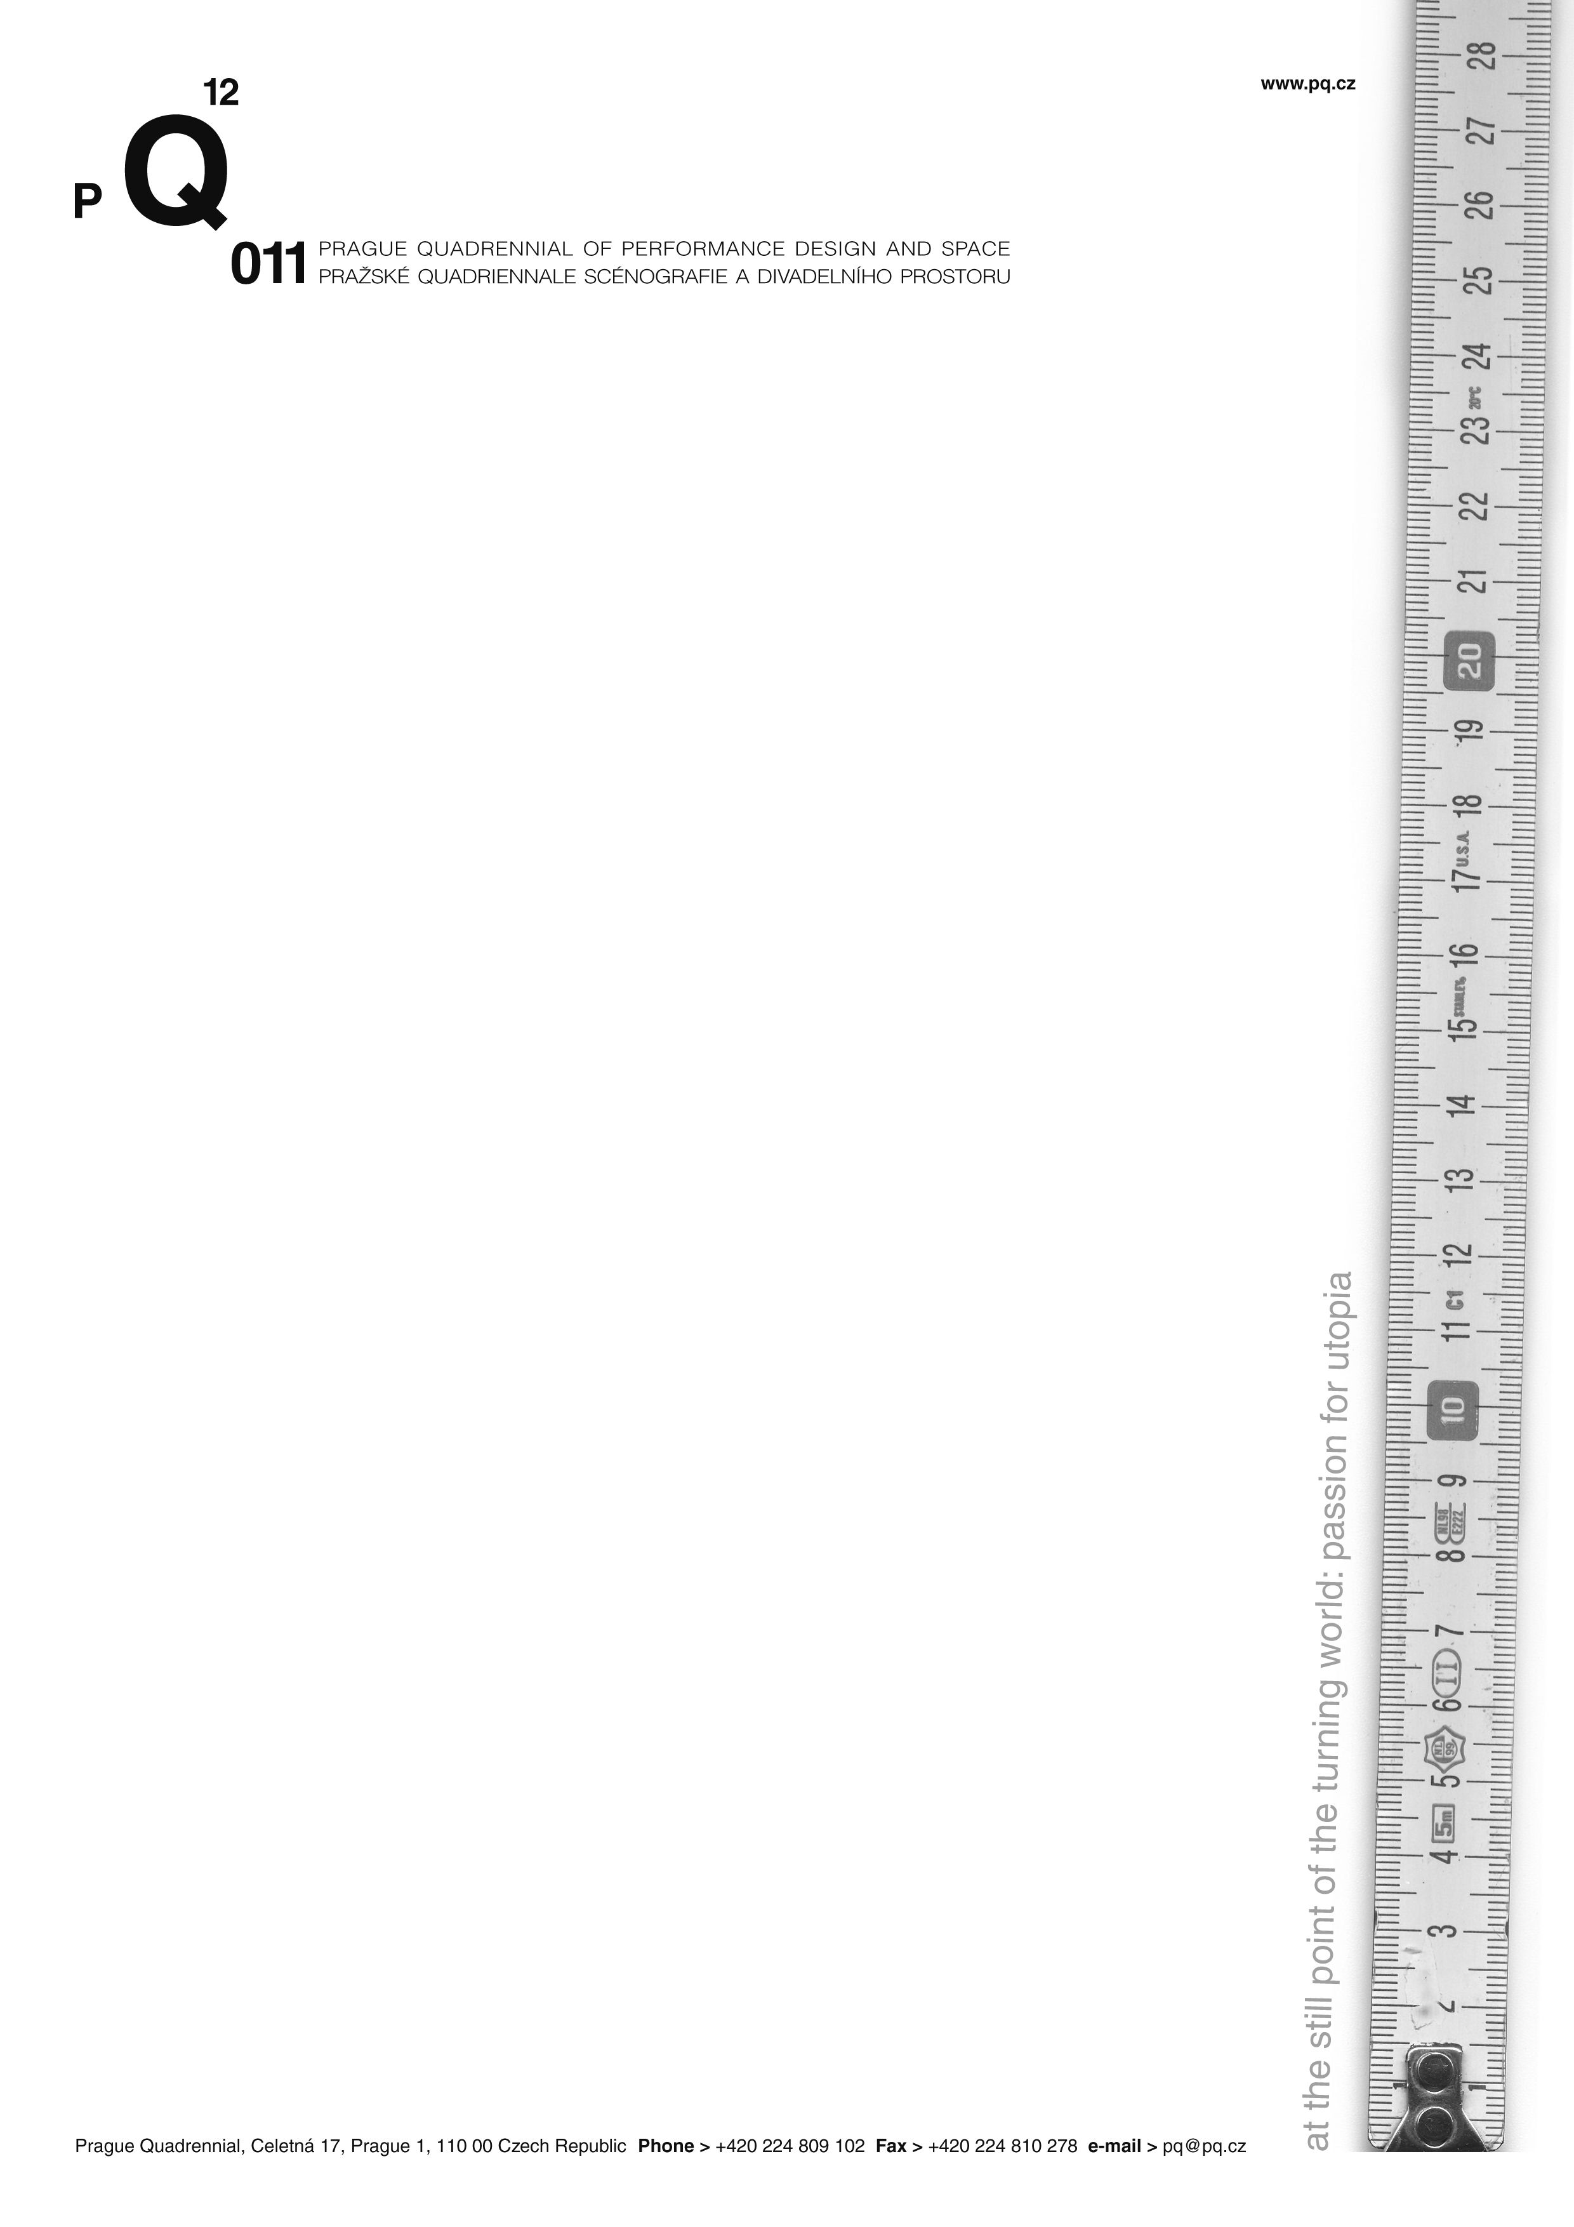

The Prague Quadrennial announces its international jury and the Expanding Scenography symposia

Prague, Czech Republic, 11.3.2010

New locations for the event, announcement of the international jury selections, and an introduction of the series of symposia, Scenography Expanding, are the latest updates from the next edition of the Prague Quadrennial of Performance Design and Space (PQ), the largest event of its kind in the world, which will take place in Prague, Czech Republic, in June 16 – 26, 2011.

The Quadrennial is adding new spaces for its exhibitions and projects and will take place throughout the whole center of Prague as well as in some non-traditional spaces. For example, the site-specific installation of the Architecture Section will take place in the beautiful Prague Crossroads-Saint Anne´s Church, run by Vaclav Havel’s Foundation VIZE. The PQ´s main competitive sections, as well as the special exhibition Extreme Costume, will take place for the first time in the functionalistic building of the Czech National Gallery - Veletrzni Palace, thus offering a new context for the Prague Quadrennial by presenting scenography as a discipline between visual and performing arts. Other sections and projects will have their premieres in galleries and public spaces in the center of Prague, The interactive installation/performances, the Intersection: Intimacy and Spectacle project, an undisciplined project of the PQ 2011 will take place at the Piazzeta of the National Theatre Prague. The Scenofest, an educational project for students and young artists, will occupy the entire Theatre Faculty of the Academy of Performing Art Prague and its surroundings. The New Scene of the National Theatre will host the Light and Sound project. More information is available on www.pq.cz.

PQ 2011 will present contemporary trends in a variety of scenography disciplines from more than 60 countries including traditional participants such as the USA, Mexico, and Germany, as well as countries that will participate for the first time, like Armenia, Kazakhstan, Columbia, and Mongolia.

Nine prominent artistic personalities from all over the world and from different performance disciplines have accepted the invitation to be part of the international jury that will present awards in various performance design fields such as scenography, costume design, theatre architecture, curatorial concept, and many others. As is tradition, the best exhibition will be awarded the prestigious Golden Triga. The jury includes, among others, director and scenographer Brett Bailey from South Africa (Golden medalist PQ 2007), Japanese architect and designer Arata Isozaki, Austrian scenographer Erich Wonder, and American theoretician Marvin Carlson.

The 2010 symposia, Expanding Scenography, have begun as the first, theoretical part of the undisciplined project – Intersection: Intimacy & Spectacle, which was organized by the PQ in cooperation with other European cultural institutions from Latvia, Great Britain, Serbia, Hungary, Italy, Finland, Switzerland, and Portugal. International artists, theoreticians, researchers, and educators will be researching contemporary forms and uses of performance from the points of view of audience, artists, and curators. The Scenography Expanding: On Spectatorship symposium was held in February in Riga, where, for example, director and theorist Alan Read and director Arpad Shilling, among others, talked about contemporary performance in relationship to space and audience. Intersection will continue with a symposium in Belgrade – Scenography Expanding: On Artists/Authors and then will be concluded in Évora with Scenography Expanding: On Curatorship. More information is available at www.intersection.cz.
------------------------------------------------------------------------------------------------------------------------What is the PQ?
The Prague Quadrennial of Performance Design and Space is the largest event of its kind in the world – a presentation of contemporary work in a variety of performance design disciplines and genres including costume, stage, lighting, sound design, and theatre architecture for dance, opera, drama, site-specific, multi-media performances, and performance art.
Since its establishment in 1967, every four years the Prague Quadrennial has presented work from more than 70 countries and five continents in the individual countries‘expositions. This large exhibition is accompanied by a wide spectrum of live events, creating space for meeting and exchange among thousands of performance and theatre professionals, with students and spectators from all over the world attending the event.

Last edition in 2007
Within the Prague Quadrennial 2007, 35,000 visitors came to enjoy over 12,000 m2 of objects, photos, videos, and live performances of work ranging between theatre and visual arts, as well as over 500 live events, workshops, performances presentations, lectures, and discussions.

The next PQ 2011
The next Prague Quadrennial will take place in Prague in 2011, during 11 days: in the 16th-26th of June. It will consist of competitive sections as the Section of Countries and Regions, the Architecture Section, and the Student Section as well as other projects: Intersection: Intimacy & Spectacle, an interactive installation/performance, Scenofest, an educational project, Light and Sound, an exhibition with workshops, presentations and discussions, and Extreme Costume, an innovative exhibition about the extreme use of extreme materials.

Prague Quadrennial 2011 International Jury

- Erich Wonder / Austria / Scenographer
- Monika Pormale / Latvia / Scenographer
- Viliam Dočolomanský / Czech Republic - Slovakia / Director
- Felice Ross / Israel / Lighting Designer
- Arata Isozaki / Japan / Architect, Scenographer, Curator, Theorist, Designer
- Carmen Romero / Chile / Director of the Festival de Teatro Santiago a Mil
- Marvin Carlson / USA / Performance Theorist
- Brett Bailey / South Africa / Director, Dramatist, Scenographer, Costume Designer, Gold Medalist at the PQ 2007
- Kevin Purcell / Australia / Composer, Sound Designer, Conductor

Contact for media:
Nathalie Frank
International Public Relations
Prague Quadrennial of Performance Design and Space
Celetná 17 | 110 00 Prague 1
Czech Republic
T +420 224 809 102
F +420 224 809 225
M+420 774 255 867
E nathalie.frank@pq.cz
www.pq.cz
for press: www.pq.cz/en/pres.html

